Animal Conservation Inquiry Project
Name of animal: __________________ Conservation Status: ________________________
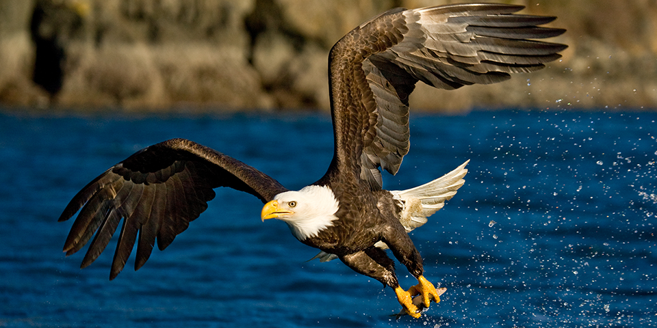
Photo Credit: © Stephen Oachs
To help us understand that human efforts can make a difference, we can consider the bald eagle population in North America. According to the American Eagle Foundation, it is estimated that in the late 1700s, there were between 300 000 – 500 000 bald eagles in North America. By the 1950s, the Smithsonian Institute stated that that number had declined to below 1000. This was due to habitat loss, illegal hunting, and the use of pesticides that made their eggs so fragile that they would break before the babies were old enough to hatch.
The bald eagle was declared endangered in 1967 and many regulations were put in place to help the eagle, and other animal, populations. Certain pesticides, especially DDT, were banned (made illegal) and hunting and trapping them was also made illegal.
Within a few decades, the bald eagle population was on the way back up. By 2006, The U.S. Fish and Wildlife Service surveyed nearly 20 000 bald eagles in the 48 U.S. mainland states. Current estimates place the total North American bald eagle population to be around 70 000. In 2007, bald eagles were changed to Least Concern on the IUCN red list. What a comeback!
In science you have already identified the Conservation Status of an animal during your animal poster project. In biology, conservation can be defined as the process of preserving and restoring natural animal habitats to aid in protecting wildlife species that live in these habitats. The Conservation Status of wildlife is continually changing as natural habitats are destroyed, new habitats are constructed, rehabilitation projects are completed, and the number of animals in the population changes. For this project you will choose an animal that is of concern (e.g. vulnerable, endangered, etc.) and research it, using the following questions to guide the process.

To which class does your animal belong? Approximately how many are left in the wild? How many (if any) are in captivity (zoos)?

Research:

Sources:

Where does your animal live (i.e. forest)? Where in the world does your animal live (i.e. west coast of North America)?

Research:

Sources:

Why does your animal have that conservation status?

Research:

Sources:

What conservation efforts/potential solutions are already happening? What is already being done to help this animal?

Research:

Sources:

Based on current efforts, what are the projected numbers for the future?

Research:

Sources:

What other efforts could be made to help this animal?

Research:

Sources:

What other animals in the same class are of conservational concern (in trouble)?

Research:

Sources:

What other animals in a similar habitat are of conservational concern?

Research:

Sources:

Should people care? What would be the effect on the environment if this animal went extinct?

Research:

Sources:

How can you effectively communicate the importance of your animal and the efforts to conserve it? i.e. video, poster, PPT, Sway, Videoscribe, etc.

